

CS308 SOFTWARE ENGINEERING

THE DESIGN DOCUMENT

COFFEE TABLE

GROUP 2: Second Group

## ASSIST. PROF. DR. KANITA KARAĐUZOVIĆ-HADŽIABDIĆ

GROUP MEMBERS: Fuad Zulić, Ahmed Aletić, Vedat Ekşi, Ahmet Z.M. Altali, Imran Dautović

SARAJEVO, 2019

# DOCUMENT REVISION HISTORY

## First Revision

*Rev1.0 March 14 ,2019 – initial version*

Our first and initial version was completely different than the current one. That version included a project that was called „Weather Forecasting“ which would be a web page and work as an information box for getting and finding all informations that people need about certain day's weather. It would include day, month, year, temperature ( celsius or fahrenheit ), run, humidity, precipitation, and some other functionalities.

**Second Revision**

*Rev1.1 March 21 ,2019 – changed version*

In our last moments of making the final decision, we find out that it would be more better and useful to take our journey on another level and make it more challenging and harder for us as a group. We decided in our group that our next goal is to make „COFFEE TABLE“ as a panel for scheduling and creating much more better and bigger things with more functionalites which we will discuss and describe after, during our project making process. We have to highlight that our dear professor cooperate with us and helped us during our decision making. Thank You for that.

**Third Revision**

*Rev 1.2 April 15, 2019 – final version*

During our regular meetings we finally decided that our project is going on right way and our final product need to be done. As we mentioned before during our „Project Documentation“ that we first were thinking of implementing weather forecasting, then after few consultations between us and our professor we decided to implement new project titled „Coffee Table“. It stayed like that until our final project meeting. Now our first object is to implement mentioned things and parts from our „Project Documentation“. We didn`t changed our project too much it stayed like it was before. We are now just working on making good and nice code which will run properly and working perfectly so that we can show our work.

# OBJECTIVES

In this part we will try to make summary or overview of our project. What are main components and what we imagined to implement so that after we can show to all of other people. As its mentioned before our project title is „Coffee Table“. In our design document it will be all said how it should look like. First of all we did our revision and we wrote that we changed our project. First one was about „Weather Forecasting“ and now second one is about „Coffee Table“ and it stayed as our final decision. We stick to that project and now working on its implementation. Second thing that will be implemented are diagrams which will show flow of our program, all methods and functions thats gonna work and make project functional. We will implement UML and sequence diagrams so that every person can graphically see whats happening inside and how its working. It will be design such nice so that even person with low level of education can understand how it will work and what are main functions that will work. At the end we will implement our UI-User Interface which will show real work of our page with all implemented functions. It`s like prototype, initial version that will be shown graphicaly so it will leave just to code it and make it as its shown. Ofcourse our „Progres Report Table“ will be attached at the end so that our professor is familiar with all our work done by each member inside of our group. Thank You.

# CLASS DIAGRAM

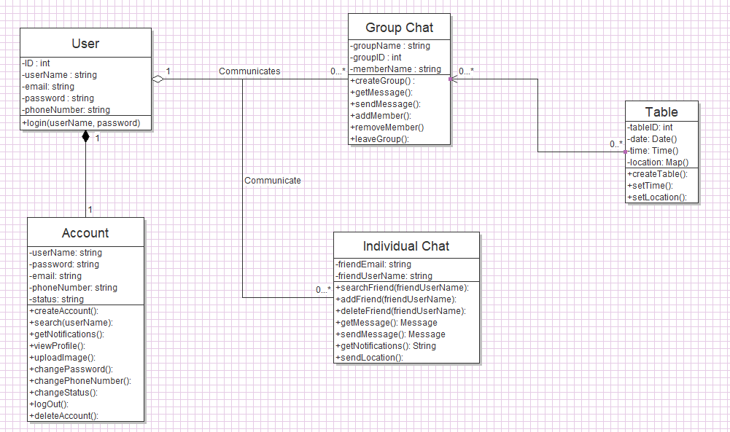

# DYNAMIC MODELS

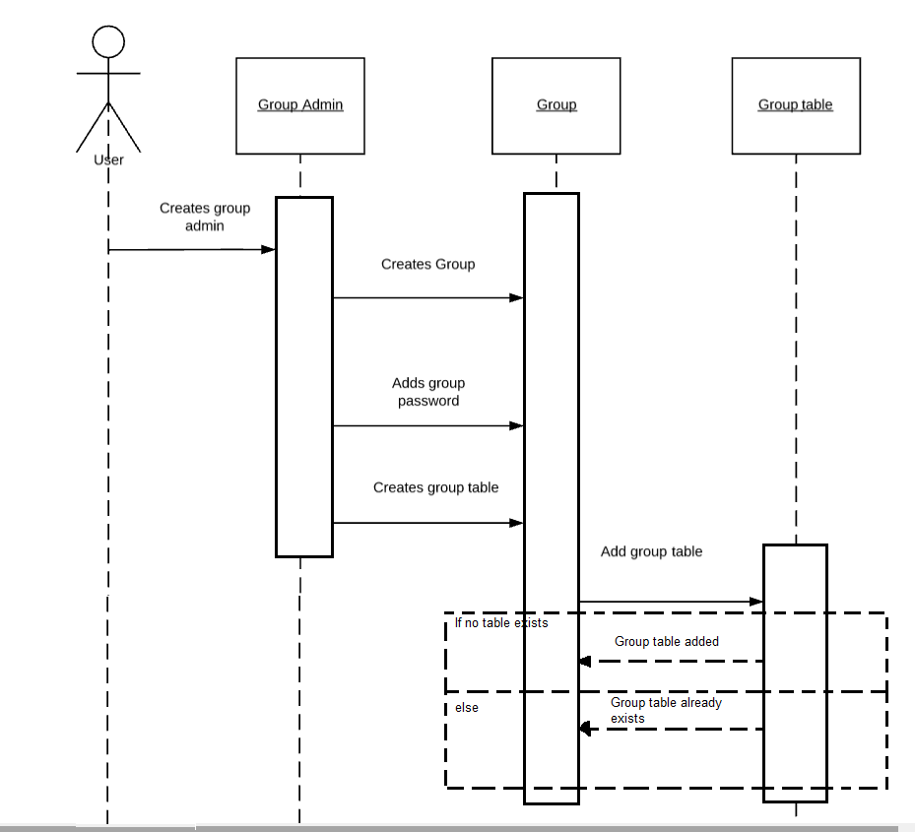

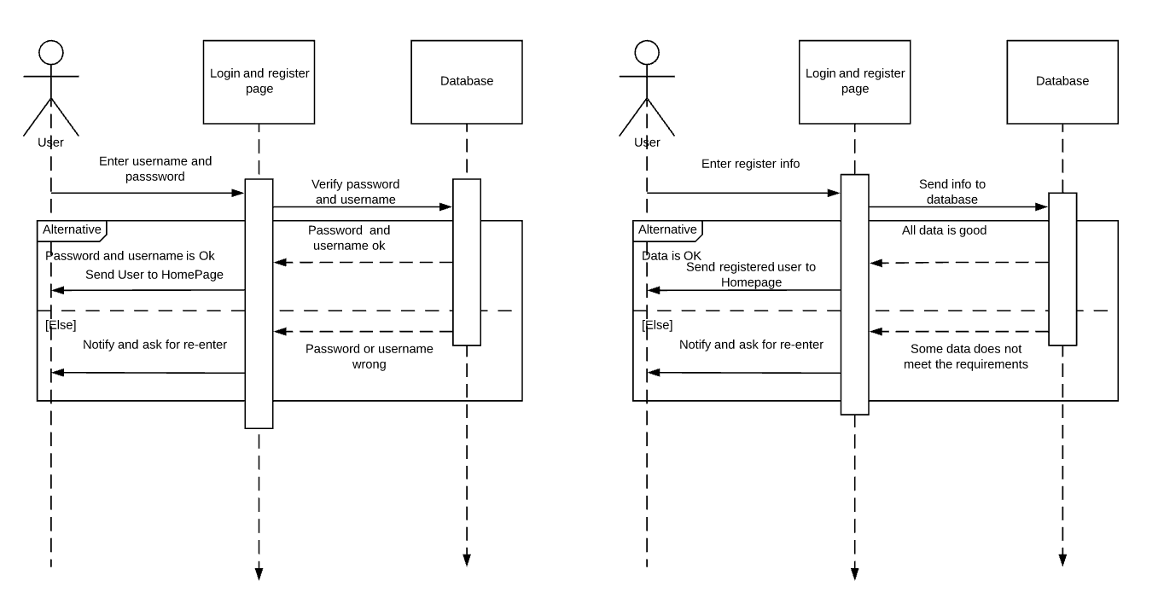

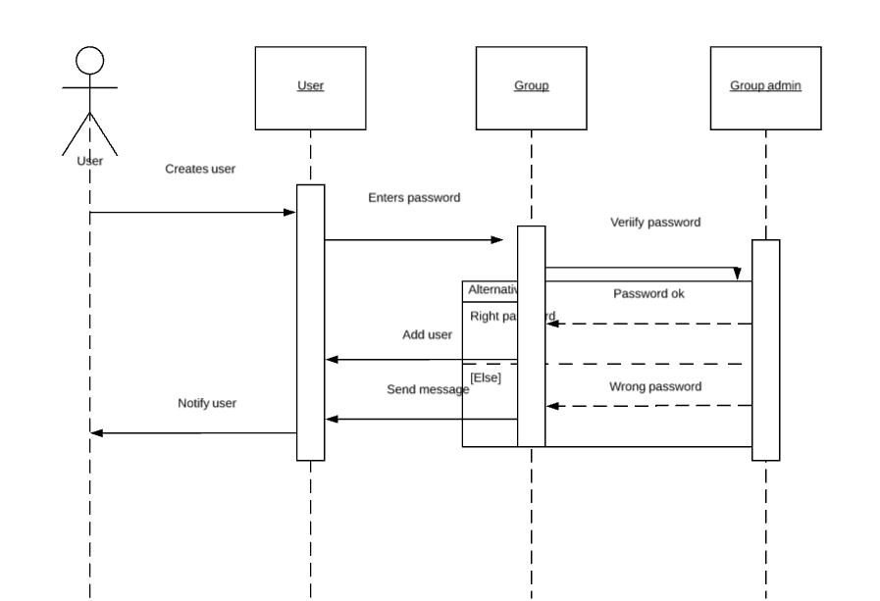

# USER INTERFACE

## WEB VERSION

**Home**

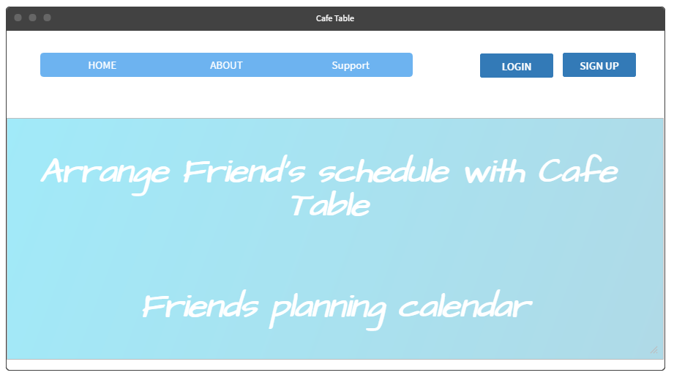

**Login**

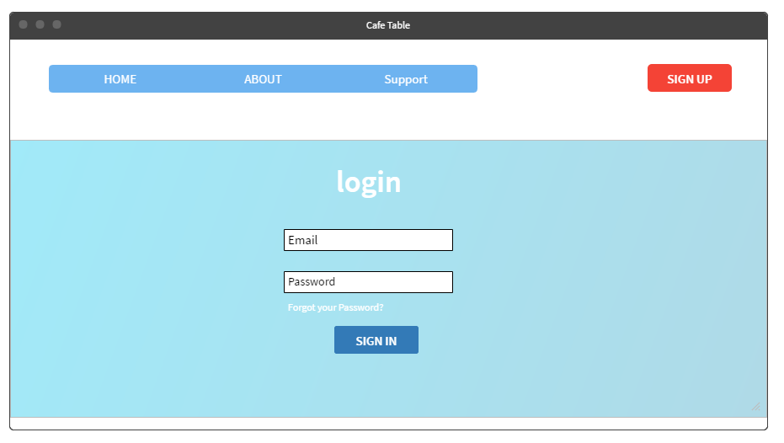

**Register**

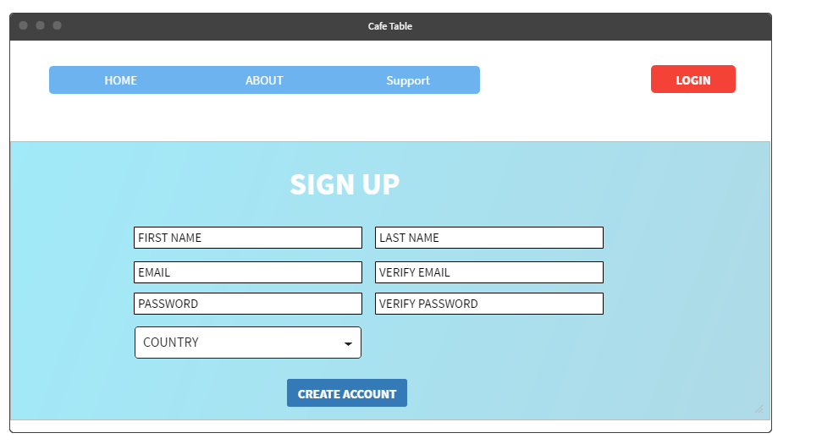

**Profile Page**

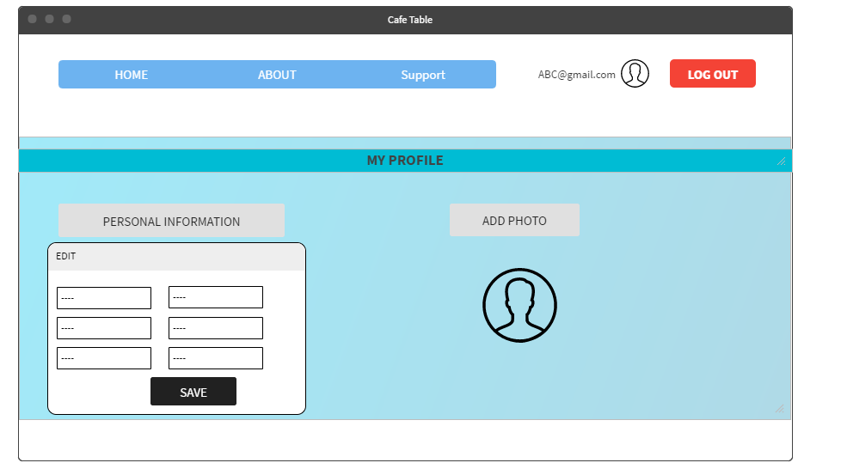

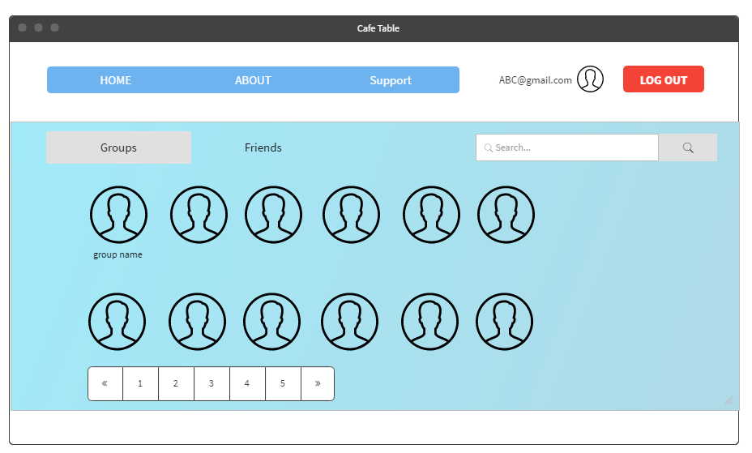

**Create a group**

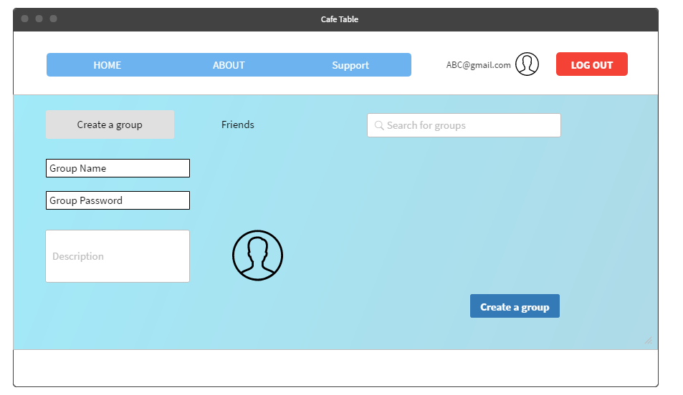

**In the group page**

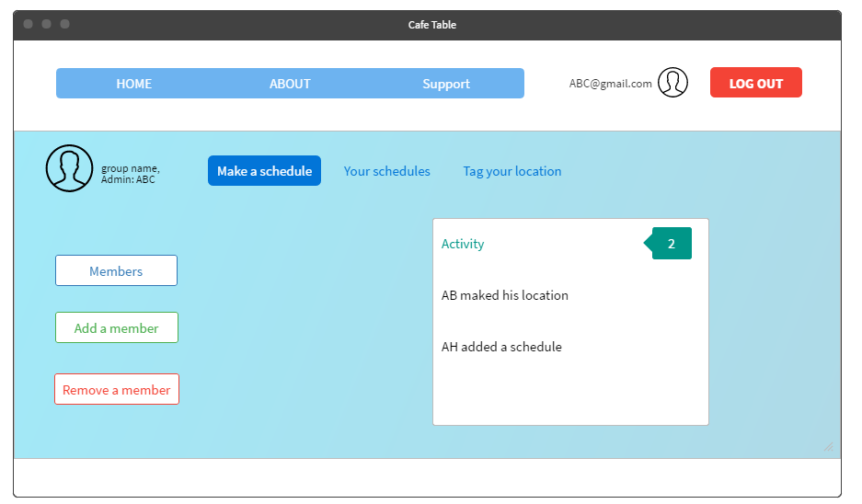

**Make a schedule**

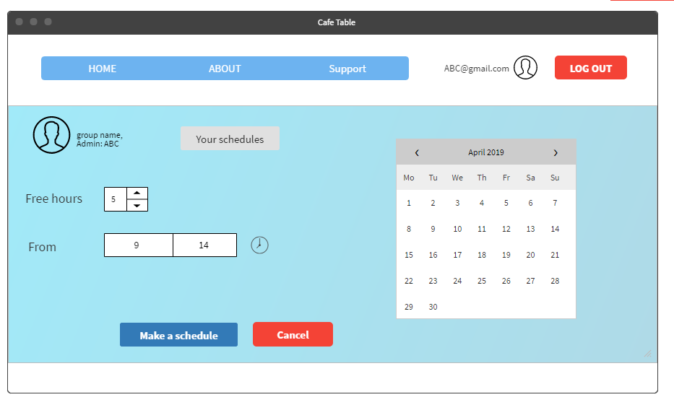

**Tag your location**

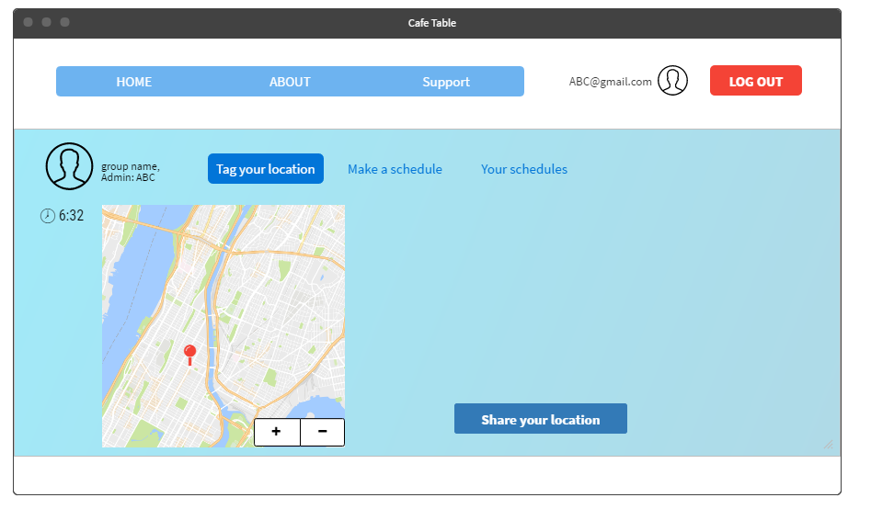

## ANDROID VERSION

*LOG IN WINDOW*

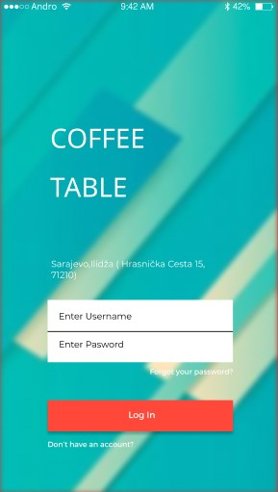

*AFTER LOGIN WINDOW*

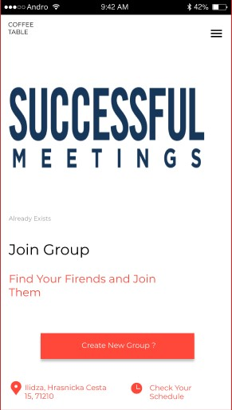

*SEARCH MENU*

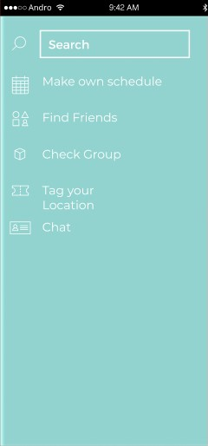

*SCHEDULE MENU*

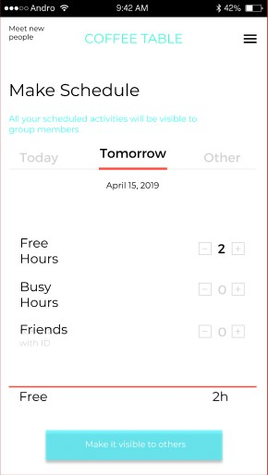

**WEATHER FORECASTING**

**Second Group**

**Meeting no: 1**

**Date: 11.3.2019**

**Members present: All members were present ( Fuad Zulić, Ahmed Aletić, Vedat Ekşi, Ahmet Z.M. Altali, Imran Dautović )**

**Members absent: No one of members were absent**

**Tasks:**

|  |  |  |  |  |
| --- | --- | --- | --- | --- |
| **Team member name** | **Task assigned** | **To be completed on** | **Last meeting tasks completed (Yes/No)** | **Signature** |
| Fuad Zulić | Make Presentation (Software Products), Presenter | 14.3.2019 | Yes |  |
| Ahmed Aletić | Make Presentation (User Interface), Trello Group Account | 14.3.2019 | Yes |  |
| Vedat Ekşi | Make Presentation (Characteristics of Weather Forecasting) | 14.3.2019 | Yes |  |
| Ahmet Z.M. Altali | Make Presentation (User Interface) | 14.3.2019 | Yes |  |
| Imran Dautović | Make Presentation (Characteristics of Weather Forecasting), Presenter | 14.3.2019 | Yes |  |

**COFFEE TABLE**

**Second Group**

**Meeting no: 2**

**Date: 14.3.2019**

**Members present: All members were present ( Fuad Zulić, Ahmed Aletić, Vedat Ekşi, Ahmet Z.M. Altali, Imran Dautović )**

**Members absent: No one of members were absent**

**Tasks:**

|  |  |  |  |  |
| --- | --- | --- | --- | --- |
| **Team member name** | **Task assigned** | **To be completed on** | **Last meeting tasks completed (Yes/No)** | **Signature** |
| Fuad Zulić | Make Project Documentation (Make table, Use Cases,Non-Functional Requirements, Release Plan) | 21.3.2019 | Yes |  |
| Ahmed Aletić | Make Project Documentation (System Requirements Specification, Functional requirements, GitHub Account) | 21.3.2019 | Yes |  |
| Vedat Ekşi | Make Project Documentation (Abstract, Document Revision) | 21.3.2019 | Yes |  |
| Ahmet Z.M. Altali | Make Project Documentation (Glossary, Introduction) | 21.3.2019 | Yes |  |
| Imran Dautović | Make Project Documentation (System Requirements Specification, Functional requirements) | 21.3.2019 | Yes |  |

**COFFEE TABLE**

**Second Group**

**Meeting no: 3**

**Date: 2.4.2019**

**Members present: All members were present ( Fuad Zulić, Ahmed Aletić, Vedat Ekşi, Ahmet Z.M. Altali, Imran Dautović )**

**Members absent: No one of members were absent**

**Tasks:**

|  |  |  |  |  |
| --- | --- | --- | --- | --- |
| **Team member name** | **Task assigned** | **To be completed on** | **Last meeting tasks completed (Yes/No)** | **Signature** |
| Fuad Zulić | Make Document Design (Dynamic Models: Sequence Diagrams) | 16.4.2019 | Yes |  |
| Ahmed Aletić | Make Document Design (System Decomposition/Design, Diagrams) | 16.4.2019 | Yes |  |
| Vedat Ekşi | Make Document Design (Document Revision History) | 16.4.2019 | Yes |  |
| Ahmet Z.M. Altali | Make Document Design (User Interface) | 16.4.2019 | Yes |  |
| Imran Dautović | Make Document Design (Objectives) | 16.4.2019 | Yes |  |